

**Final Year Project Report**



**Development of a C++ based user-interface for a plasma simulation tool**



**Author: Zhang, Junming (ID: 201138928)**

**Project Supervisor: Dr.Mark Bowden**

**Project Assessor: Dr.Kirsty McKay**

**Department of Electrical Engineering and Electronics**

**18 April 2017**

**Declaration of academic integrity**

**I confirm that I have read and understood the University’s Academic Integrity Policy.**

**I confirm that I have acted honestly, ethically and professionally in conduct leading to assessment for the programme of study.**

**I confirm that I have not copied material from another source nor committed plagiarism nor fabricated, falsified or embellished data when completing the attached piece of work. I confirm that I have not copied material from another source, nor colluded with any other student in the preparation and production of this work.**

**SIGNATURE……………………………………………………………………………………… DATE ……………………………………………………………………………………….**

# 

# Abstract

An existing microplasmas simulation tool which developed by the technological plasma team will generate considerable output data in various formats. Therefore, a user-friendly interface is needed by relevant researchers and industry users.

The aim of this report is to describe the preliminary development procedures of this user-friendly interface and this report includes six parts which are project description, methodology, project plan, project rationale with the relevance of industry, literature review and the working results in the first three weeks.

The future work of this project will perform according to the project plan in continuing research.

Contents

Abstract 1

1. Introduction 3

2. Project Description 4

2.1 Problem statements 4

2.2 Project overview 7

3. Methodology 8

3.1 Tools 8

3.1.1 C++ based software developing tools 8

3.2 Software Development Process 8

3.2.1 Software requirements 8

3.2.2 Design 10

4. Project Plan 11

5. Project Rationale and Industrial Relevance 12

6. Literature Review 13

6.1 The web-based user interface for EAST plasma control system 14

6.2 Web interface for plasma analysis codes 15

6.3 User control interface for W7-X plasma operation 15

6.4 Literature reviews appendix 15

7. Results 16

7.1 Preliminary research of plasma 16

7.1.1 Plasma and Micro Discharge 2D(md2d) model 16

7.2 Preliminary developing of software 18

7.2.1 Rapid loading text files function 18

8. Conclusion 20

References List 21

Appendices 22

Appendix 1. The specification report form 22

Appendix 2. A Gantt chart preferable produced by MS project 26

Appendix 3. The risk assessment form 27

Appendix 4. Ethical approval questionnaire 31

# Introduction

The objective of this project is to build a C++-based user interface for helping plasma researchers obtain a simulated result more efficient. This interface would serve as an accessory program to process output data from the plasma simulation tool Plasimo.

## 1.1 Background

Plasma is the fourth fundamental state of matter which consists of neutral ions, electrons, photons and ions.

Figure 1 illustrates the general type of plasma which has the vacuum chamber, pump, gas flow system and electrodes.

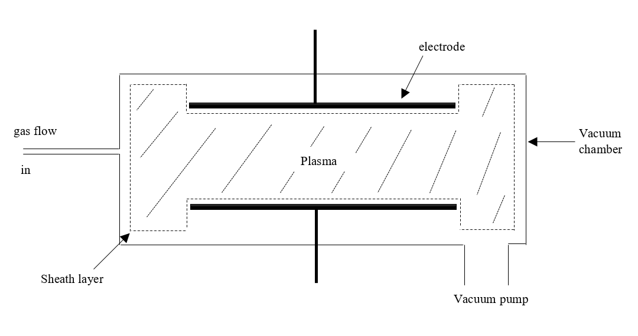

Figure 1. The general type of plasma structure

Plasimo is a powerful program to provide the transient and steady-state simulation of microplasma in different dimensional geometries [1].

Figure 2 shows the main window of Plasimo 5.0 developer version. User could load different models of plasma to run the simulation. At the same time, observe the changing process and obtain the simulated result.

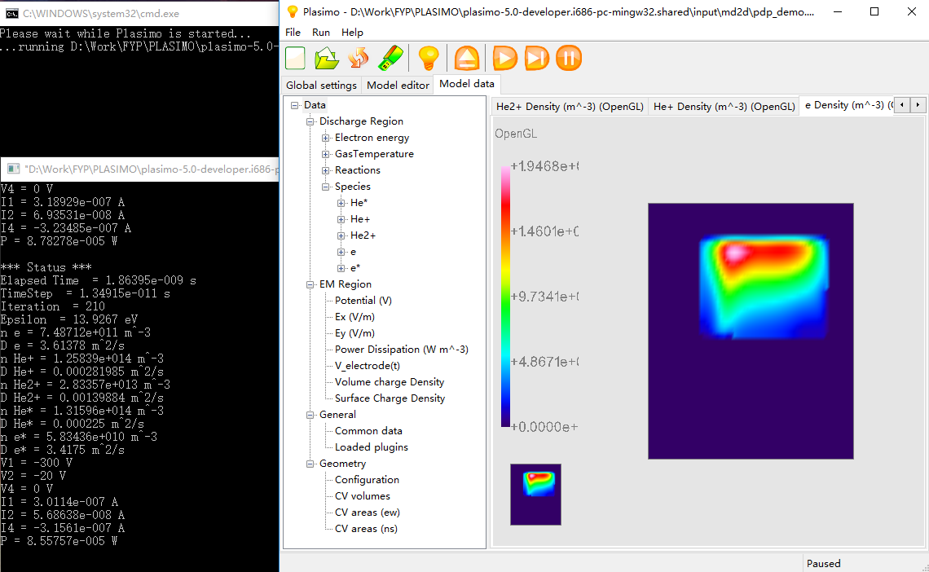

Figure 2. The main window of Plasimo developer 5.0 version

Supervisor Dr. Mark recommend the Micro Discharge 2D (pdp_md2d) for the target model in this project. It is a time- dependent model and the function of it is solving particle transport problem in conjunction [2].

Figure 3 display the simulated result of pdp_md2d model. Plasimo will generate 68 output files as “text” and “out” format in this case.

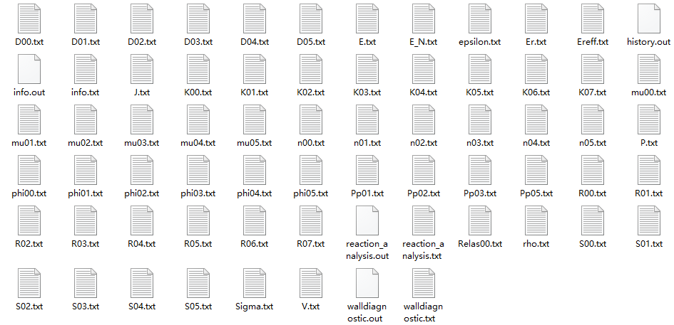

Figure 3. Simulated output files of pdp_md2d model

In addition, the plasma has various significant features, which are:

A large amount of output files was generated through the Plasimo simulation tool and the explanation of each output file is shown in Table 1. It describes 24 properties of plasma. However, the most basic plasma properties are:

* Gas density and pressure
* Neutral particle density
* Electron density
* Electron energy and electron temperature
* Ion density
* Plasma potential
* Ionization ratio

Lots of simulated information are stored in these files detailedly. The explanation of each file is shown in Table 1[1].

|  |  |
| --- | --- |
| n00.txt | electron energy density [J m-3] |
| phi00.txt | electron energy flux density [W m-2] |
| S00.txt | electron energy source [W m-3] |
| D00.txt | electron energy diffusion coefficient [W m2] |
| mu00.txt | electron energy mobility coefficient [J m2 V-1 s-1] |
| Relas00.txt | rate of electron energy loss from elastic collisions [W m-3] |
| epsilon.txt | mean electron energy [J] |
| n01.txt | density for species 1 [m-3] |
| S01.txt | source for species 1 [m-3 s-1] |
| D01.txt | diffusion for species 1 [m2 s-1] |
| mu01.txt | mobility for species 1 [m2 V-1 s-1] |
| phi01.txt | flux for species 1 [m-2 s-1] |
| R00.txt | reaction rate for reaction 1 [m-3 s-1] |
| K00.txt | reaction rate coefficient for reaction 1 [m3 s-1] |
| Pp01.txt | power dissipation for species 1 [W m-3] |
| P.txt | dissipated power density [W m-3] |
| J.txt | current density [C s-1 m-3] |
| V.txt | potential [V] |
| E.txt | electric field [V m-1] |
| Er.txt | reduced electric field E/p [V m-1 Pa-1] |
| E_N.txt | reduced electric field E/N [V m2] |
| rho.txt | volume charge density [C m-3] |
| sigma.txt | surface charge density [C m-2] |
| info.txt | the averaged values written with the user-specified frequency |
| info.out | the averaged values |
| history.out | gives the calculated variables as a function of time |

Table 1. The explanation of each simulated output file from plasimo user guide

For plasma model md2d, it needs the simulation for a long time to run the md2d model in the plasimo. In addition, there are total 68 files with 32.9 MB data and different files represent different data of plasma as shown in Table 1. Moreover, it contains a number of useless data. Hence, researchers and industry users will be complicated to read these data.

## 1.2 Problem statements

## 1.3 Literature Review

## 2.2 Project overview

According to the problem statements, a user-friendly interface is needed to develop. Therefore, the aim of this project is to develop a practical C++ based user-interface to help researchers and industry users to obtain significant output data effectively.

This project can be divided into two main objectives:

* The first is research of plasma to select useful data from various output data because the significant data is needed to pick at the beginning to reduce the workload of programming. Hence, the initial phase of this project will include background reading and plasma discharges researching.
* Second and the key aspect of this project is developing a widely accessible user-interface to help researchers and industry users. The ability to develop an interface by using C++ based tools should be trained.

In order to finish this project within 20 weeks, it needs developer working through combined research work with programming skill. Meanwhile, the report and presentation of this project should be prepared and then it will discuss more detail about how to realize this project in the Methodology part.

# Methodology

## Tools

### 3.1.1 C++ based software developing tools

The requirements of this project is under C++ developing environment. There are three main tools will be used to build this user-interface.

#### 3.1.1.1 Microsoft Visual Studio Community 2013

Visual Studio is the most popular integrated development environment on Windows. It will be used for the major developing tool in this project.

#### 3.1.1.2 Qt 5.7.0

Qt is a framework of cross-platform C++ graphical user interface (GUI) application development. It contains the fundamental technology of GUI which is used to render the interface [2].

#### 3.1.1.3 openGL

Open Graphics Library (OpenGL) is the most widely 2D and 3D Application Program Interface (API). It could be applied in lots of platforms such as Window, Linux and MacOS.

## Software Development Process

### 3.2.1 Software requirements

This program is used to display required data by processing considerable text files and it should be used to select significant data of plasma to researchers and industry users.

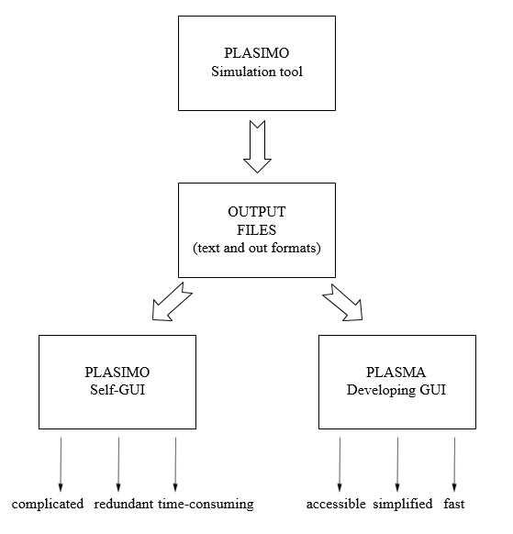

Figure 3. The general analysis of this project

According to characters analysing of this GUI in Plasimo, it could find that it is complicated because new users are difficult to use this software without a handbook. At the same time, redundant output data will be generated through the simulated process, researchers and users cannot find useful data directly. For m2de model, it spends 10 minutes to complete simulated process. Moreover, there still has other models of plasma are more time-consuming.

In order to solve these problems, the requirement of software is developing an accessible, simplified and fast GUI to provide useful data to users. The analysis process is shown in Figure 3 and the design process of this project will follow this analysis.

### 3.2.2 Design

The characters of accessible, simplified and fast will be considered as the key points of the design process to realize requirements of this software,

#### 3.2.2.1 User-interface building

In order to develop an accessible user-interface, it should obey the Eight Golden Rules of Interface design [3].

* Strive for consistency
* Cater to universal usability
* Offer informative feedback
* Design dialogs to yield closure
* Prevent errors
* Permit easy reversal of actions
* Support internal locus of control
* Reduce short-term memory load

In addition, interfaces researching of different software especially research-based software are significant. Therefore, it needs to spend more time in comparing advantages and disadvantages of various interfaces in the future research.

#### 3.2.2.2 3D graphical display function

For technology users, the output simulated data of plasma should be displayed intuitively. Therefore, a 3D graphical model could be treated as a simplified and intuitionistic way to research plasma and then users could observe the changing process of this particular plasma model.

#### 3.2.2.3 Rapid loading text files function

An Excellent response time of a software should be considered as an important standard. Numerous output files will be generated by md2d plasma simulation and other models of plasmas may spend longer time to obtain results. In addition, there are 68 output files of one simulated plasma. Hence, the rapid text files loading function is needed to research and develop a fast interface.

# Project Plan

4.1 FYP

4.1.1) Preparatory Work

4.1.1.1) Obtain plasma simulation tool and relevant reading materials

4.1.2) Research Work

4.1.2.1) Weekly background reading for plasma discharges.

4.1.2.2) Investigating significant data in numerous output file.

4.1.2.3) Investigating Interface of learning, researching and factory software.

4.1.2.4) Literature review.

4.1.2.4) Learning of related software include C++ based visual studio, openGL and Qt.

4.1.3) Developing Work

4.1.3.1) Write software requirements

4.1.3.1.1) Software specifications

4.1.3.1.2) Software analysis

4.1.3.2) Design

4.1.3.2.1) Rapid loading text files function developing.

4.1.3.2.2) UI design

4.1.3.2.3) User-interface developing.

4.1.3.2.4) Data dispose function developing

4.1.3.3) Testing and improving

4.1.3.3.1) Program test and debug.

4.1.3.3.2) UI optimization

4.1.3.3.3) System optimization

4.1.4) Report Work

4.1.4.1) Writing project specification report form.

4.1.4.2) Writing Preliminary report.

4.1.4.3) Weekly virtual log book.

4.1.4.4) Preparing presentation.

4.1.4.5) Creating poster.

4.1.4.6) Writing a final report.

*The complete project plan will show in Appendix 2 with the Gantt chart.*

# Project Rationale and Industrial Relevance

In this project, the main areas are computer science and physics, which are both significant branches of human scientific and technological development. In addition, the relationship between these two areas and EEE are not similar. Therefore, this is a challenging opportunity to test the learning ability of new areas as an EEE undergraduate.

For the future development, this project will create a greater contribution because there are many applications on the plasma.

For example, biomedicine is an important application of microplasmas. The plasma needle could be used to generate reactive species such as excited molecules, radicals and ions [4]. In this case, the properties of the plasma needle can be displayed and investigated from simulation tool which is shown in Figure 4.

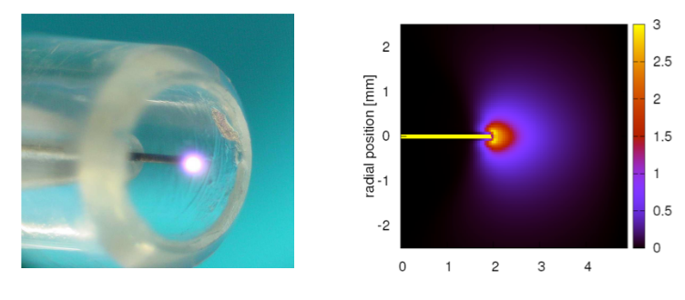

Figure 4. Simulation of the plasma needle

Source: Numerical description of discharge characteristics of the plasma needle

# Literature Review

At the preliminary stage, three literatures which related to this project have been found through the university library database. Two of them are related to web-based user interface and the remaining one is related to software interface developing of plasma.

## 6.1 The web-based user interface for EAST plasma control system

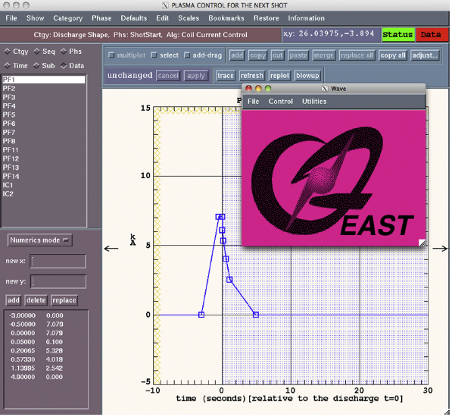

Figure 5. The IDL user interface of EAST

The report of this system illustrates the clear design process of the GUI and it provides an idea to this project about design a software interface of plasma. In this report, the excellent workflow was built to express the process of the whole system and the ideas of function. However, this interface still has some disadvantage need to be improved and avoided in this project such as the completed interface is not as adequate quality as their design process because the narrow space cannot display too many data.

## 6.2 Web interface for plasma analysis codes

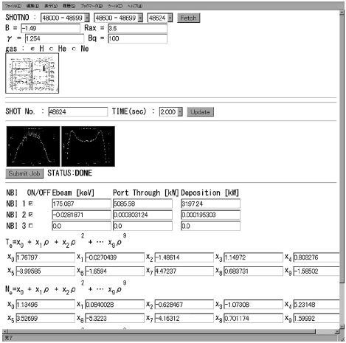

Figure 6. The Web interface for FIT code

This interface could display the data of plasma into formulas and line charts. Therefore, it compensates the disadvantage of EAST plasma control system. The Web-based interface is developed by JavaScript, but the concept of the GUI design process is worth to study.

## 6.3 User control interface for W7-X plasma operation

This report describes the detailed design process of GUI and it could support convenient interface to control the operation of plasma. At the beginning of this report, it describes how to reduce the workload of users through optimizing the procedures of software. Therefore, investigating the requirements of users is an important step to develop a great GUI.

## 6.4 Literature reviews appendix

* R.R. Zhang, B.J. Xiao, Q.P. Yuan, F. Yang, Y. Zhang, R.D. Johnson, B.G. Penaflor, " The web-based user interface for EAST plasma control system", *J. Appl. Phys.* February 2014, DOI: 10.1016/j.fusengdes.2014.02.070
* M. Emoto, S. Murakami, M. Yoshida, H. Funaba and Y. Nagayama., " Web interface for plasma analysis codes", *J. Appl. Phys.* vol. 83, no.2-3, pp. 453-457, April 2008, DOI: 10.1016/j.fusengdes.2007.10.008
* S. Anett, L. Heike, S. Jörg, " User control interface for W7-X plasma operation", *J. Appl. Phys.* 2007, DOI: 10.1016/j.fusengdes.2007.05.052

# Results

Plasma is a new area of the EEE student. This project contains two main parts which are deep learning about plasma and user-interface developing.

At the preliminary stage, researching basic properties of plasma and developing specific function are two main results.

## 7.1 Preliminary research of plasma

### 7.1.1 Plasma and Micro Discharge 2D(md2d) model

#### 7.1.1.1 Plasma definition

#### 7.1.1.2 md2d model definition

## 7.2 Preliminary developing of software

### 7.2.1 Rapid loading text files function

There are 68 text files with 32.9 MB data of simulated md2d model. Moreover, other models of plasma may generate more data. Hence, the stable and fast text load command should be chosen to improve the response speed of this software

After searching on the internet, it can be found that there are four commands to load the text file in C++ environment.

In order to test these commands, it needs to generate a text file with 10000000 random numbers first, and the different loading commands will be used to test the loading time of this files.

Scanf is a normal loading command in C++.

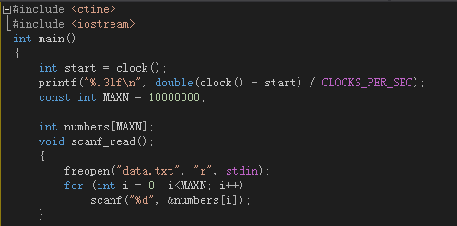

Figure 8. Code of testing scanf command

cin is the most common loading command in C++.

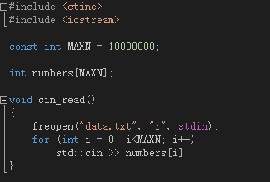

Figure 9. Code of testing cin command

Fread command is used to load all data into one string

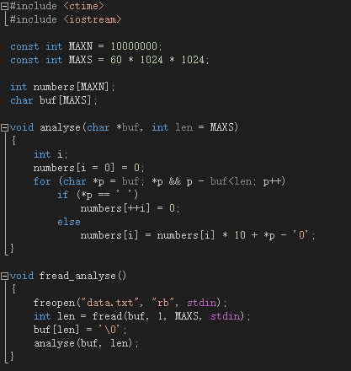

Figure 10. Code of testing fread command

|  |  |
| --- | --- |
| Visual Studio 2013 command | Time (s) |
| scanf | 3.8 |
| cin | 21.6 |
| fread | 0.42 |

Table 2. Testing results of loading command.

According to the analysis of these result, it could find that command fread has the fastest rate to load files. Thus this command will be used firstly to loading data.

However, this is only the preliminary test of this function. All tests focused on one text file, but there are 68 text files of the simulated output. Therefore, the rapid loading text files function still needs further development.

# Conclusion

In general, this preliminary report is the initial guide of the Final Year Project which is the development of a C++ based user-interface for a plasma simulation tool. It has been divided into six parts include the project description, methodology, relevant plan, project rationale, literature review and the result. The aim and objective are developing a user-friendly interface to help researchers and industry users to investigate plasma effectively.

The ability to formulate a project plan and preliminary work are trained through this process. After complete this report, the understanding of the project will increase, so that it will provide convenience to the future development. However, it is still the beginning of this FYP, the details about interface design and corresponding programming still need more time to develop.

# References List

[1] <https://plasimo.phys.tue.nl/plasimo_overview.html>

[2] The Plasimo Team. IEEE Citation Reference [online]. Available: <https://plasimo.phys.tue.nl/physics/md2d/index.html> (accessed 14th October 2016)

[1] The Plasimo Team. (2014 April) IEEE Citation Reference [online]. Available: <https://plasimo.phys.tue.nl/generated-docs/plasimo-5.0.0/misc-docs/user_guide.pdf> (accessed 14th October 2016)

[2] D. Molkentin, “*The Book of Qt 4: The Art of Building Qt Applications*”. San Francisco, USA: No Starch Press, 2007, ISBN-13 978-1593271473

[3] B. Shneiderman. (2010) IEEE Citation Reference [online]. Available: <https://www.cs.umd.edu/users/ben/goldenrules.html> (accessed 14th October 2016)

[4] W.J.M. Brok, M.D. Bowden, J. van Dijk, J.J.A.M. van der Mullen and G.M.W. Kroesen., " Numerical description of discharge characteristics of the plasma needle", *J. Appl. Phys.* vol. 98, 2005, DOI: 10.1063/1.1944218

# Appendices

## Appendix 1. The specification report form

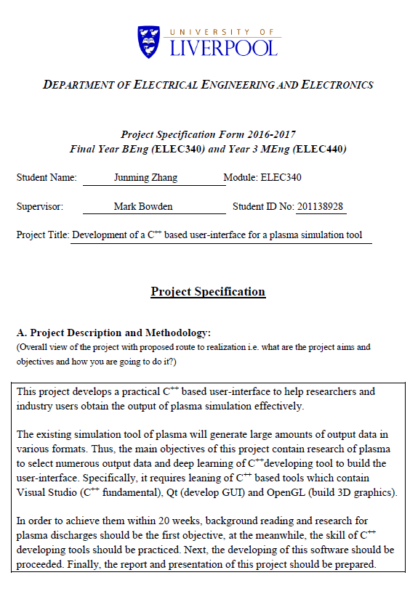

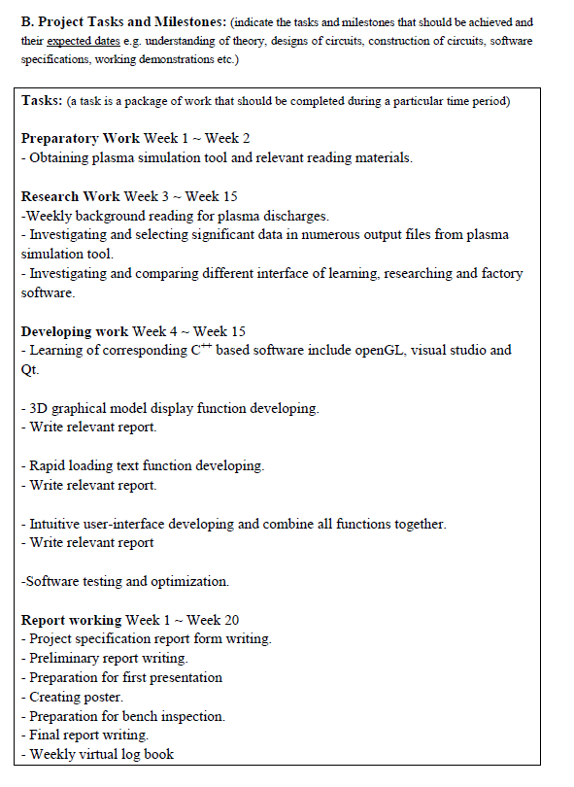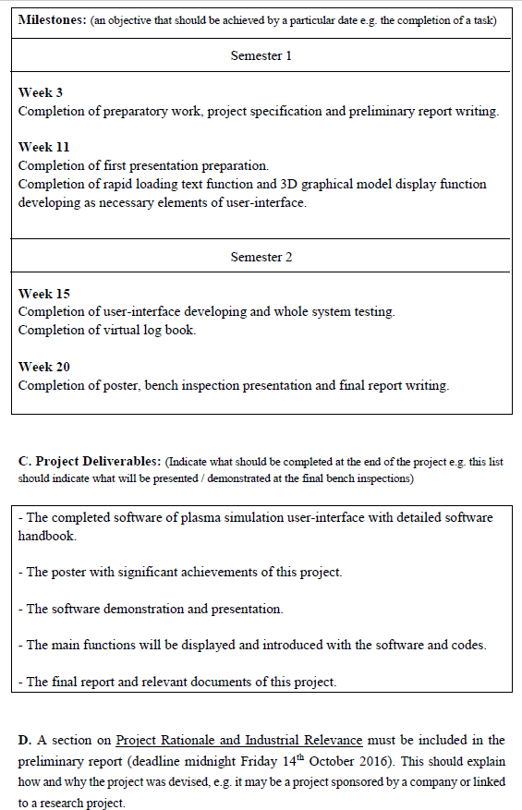

## Appendix 2. A Gantt chart preferable produced by MS project

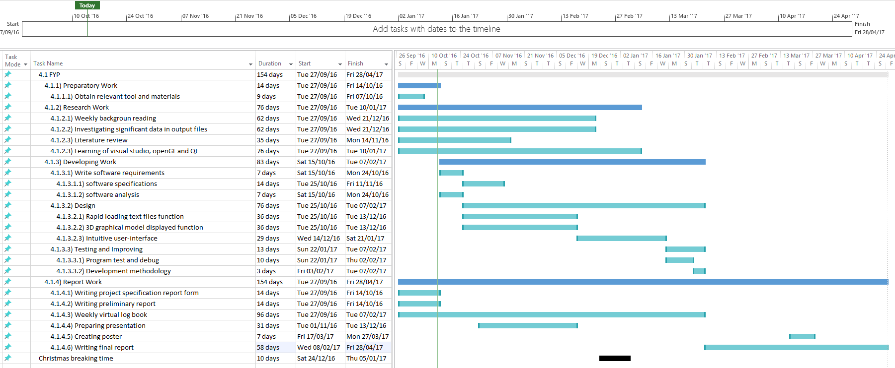

## Appendix 3. The risk assessment form

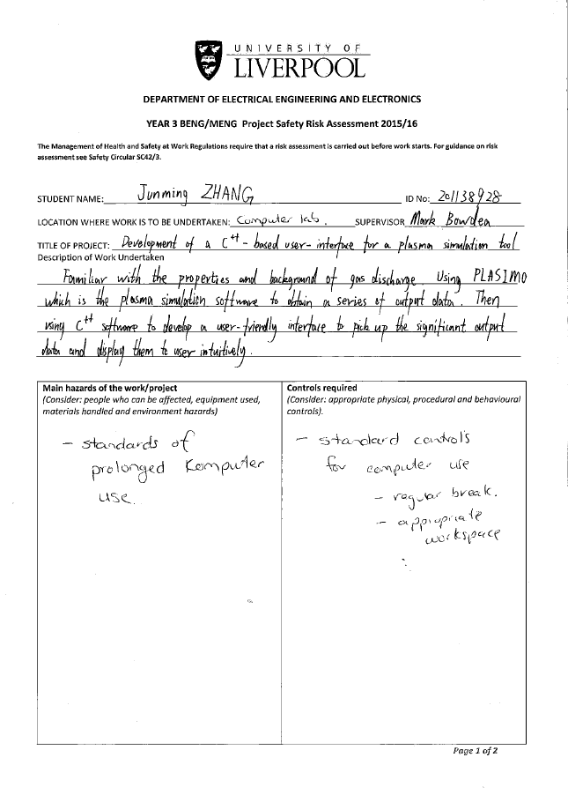

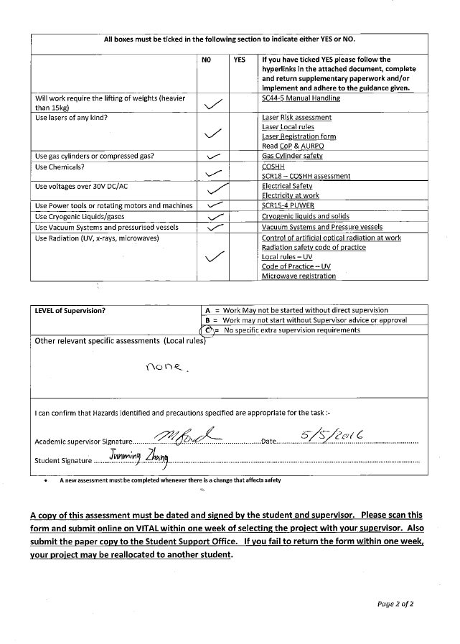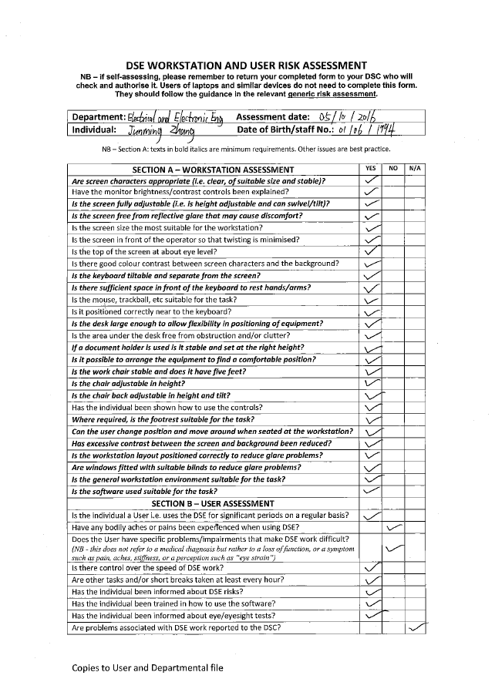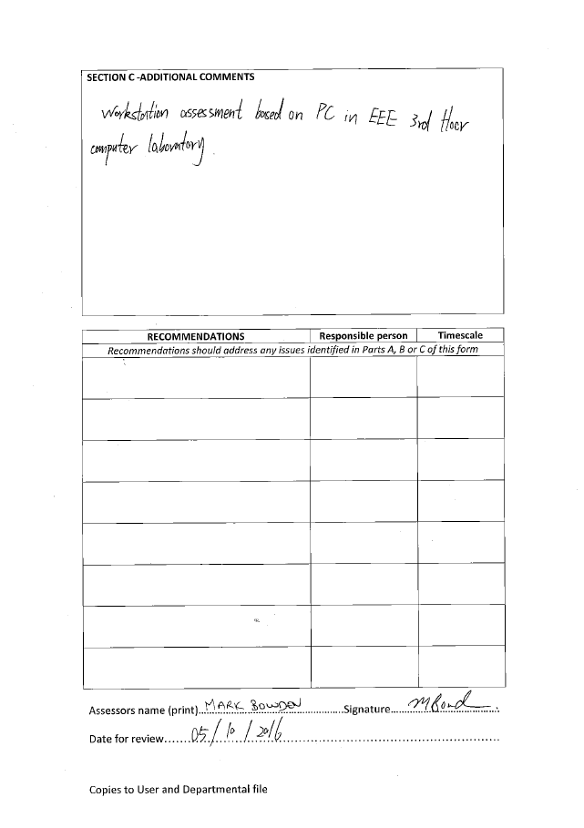

## Appendix 4. Ethical approval questionnaire

